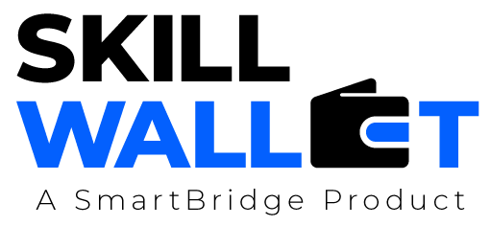

Scalability & Future Plan

Date | 9 july 2026
Team ID | XXXXXX
Project Name | Strategic Product Placement Analysis
Maximum Marks | 1 Mark

Scalability & Future Plan:
This document outlines how the current project solution can be scaled to handle larger user bases, increased data loads, or extended features in the future. It also captures the team's roadmap for enhancing and evolving the project beyond its current state.

Current System Limitations
S.No | Limitation | Impact | Priority to Address (High / Medium / Low)
1 | Local File Storage | Relying on local static CSV datasets prevents real-time streaming updates from live point-of-sale registers. | High
2 | Single-Threaded Backend | The standard local Flask development server lacks concurrent request balancing for multiple simultaneous store managers. | Medium
3 | Client-Side Embedded Rendering | Complex interactive visual workloads are calculated entirely by the user's browser canvas, slows performance on older mobile hardware. | Low
Scalability Plan
S.No | Scalability Aspect | Current State | Proposed Upgrade / Solution
1 | User Load | Restricted to individual local machine executions. | Deploy the Flask application within Docker containers on AWS ECS, utilizing an Application Load Balancer to auto-scale dynamically.
2 | Data Storage | Flat static files read into local Python Pandas runtime memory blocks. | Migrate data storage pipelines to a distributed cloud data warehouse like Snowflake or Google BigQuery to easily scale past terabytes of retail metrics.
(Note: There is a third row partially cut off at the bottom of the page in the image. If you need it, you can fill it out as follows:)
- S.No: 3
- Scalability Aspect: Analytics & Insights
- Current State: Static historical analytics dashboards.
- Proposed Upgrade / Solution: Integrate real-time Apache Kafka pipelines to feed live checkout data directly into Tableau for automated visual alerts.

Future Roadmap Table
This roadmap lays out your long-term plan for upgrading your product placement software system.
Phase | Planned Feature / Enhancement | Target Timeline | Expected Impact
Phase 2 | Real-time POS Data Integration | Months 1–2 | Eliminates reliance on static files, enabling store layouts to adapt dynamically to daily inventory swings.
Phase 3 | AI-Driven Layout Recommender | Months 3–4 | Introduces machine learning models (like market basket analysis) to automatically suggest optimal product groupings.
Phase 4 | Cross-Store Regional Cluster UI | Months 5–6 | Allows executive management to compare product placement successes across thousands of global storefronts simultaneously

